K L UNIVERSITY
FRESHMAN ENGINEERING DEPARTMENT

A Project Based Lab Report On

Mini Arcade-game-Suite

SUBMITTED BY:

ID NUMBER NAME
2500032419 M. SATYA SREE NIKESH
2500032434 M. KRISHNA CHAKRADAR
2500032452 S. SAI GOUTAM
2500032464 N. BHUVANESWARI

UNDER THE ESTEEMED GUIDANCE OF Dr. SIREESHA GUNDU
ASSISTANT PROFESSOR



KL UNIVERSITY
Green fields, Vaddeswaram – 522 502 Guntur Dt., AP, India.

DEPARTMENT OF BASIC ENGINEERING SCIENCES



CERTIFICATE

This is to certify that the project based laboratory report entitled “ Smart Banking Management System (SBMS)” submitted by M. SATYA SREE NIKESH, M. KRISHNA CHAKRADAR S.,SAI GOUTAM , N. BHUVANESWARI bearing Regd. No.2500032419, 2500032434, 2500032452, 25000323464to the Department of COMPUTER SICENCE ENGINEERING , KL University in partial fulfillment of the requirements for the completion of a project based Laboratory in “Computational Thinking for Problem Solving (25SC2007)” course in I B Tech II Semester, is a Bonafede record of the work carried out by him/her under my supervision during the academic year 2025 – 2026.

PROJECT SUPERVISOR HEAD OF THE DEPARTMENT Dr. SIREESHA GUNDU Dr. D. HARITHA

ACKNOWLEDGEMENTS

It is great pleasure for me to express my gratitude to our honorable President.

Sri. Koneru Satyanarayana, for giving the opportunity and platform with facilities in accomplishing the project-based laboratory report.
I express sincere gratitude to our Director Dr. A. Jagdeesh for his administration towards our academic growth.
I express sincere gratitude to our Coordinator and HOD-BES Dr. D. Haritha for her leadership and constant motivation provided in successful completion of our academic semester. I record it as my privilege to deeply thank you for providing us with the efficient faculty and facilities to make our ideas into reality.
I express my sincere thanks to our project supervisor Dr. Sireesha Gundu for her novel association of ideas, encouragement, appreciation, and intellectual zeal which motivated us to venture this project successfully.
Finally, we are pleased to acknowledge our indebtedness to all those who devoted themselves directly or indirectly to making this project a success.

NAME: M. SATYA SREE NIKESH
M. KRISHNA CHAKRADAR
S. SAI GOUTAM
N. BHUVANESWARI

IDNO: 2500032419
250032434
2500032452
2500032464

ABSTRACT

The Smart Banking Management System (SBMS) is a modern software solution designed to simplify and automate banking operations. It enables users to perform essential activities such as account creation, deposits, withdrawals, and fund transfers efficiently. The system ensures data accuracy and security through proper validation and authentication mechanisms. By reducing manual intervention, it minimizes errors and improves service speed. SBMS enhances user convenience by providing quick access to financial information. Overall, it contributes to a more reliable and efficient banking experience.
The SBMS project focuses on developing a digital platform that replaces traditional banking methods with automated processes. It allows banks to manage customer records, transactions, and account details effectively. The system is designed with user-friendly interfaces and secure login features to ensure safe access. It supports real-time updates and maintains transaction history for better tracking. This system reduces paperwork and operational delays significantly. It serves as an efficient tool for modern banking environments.
Smart Banking Management System is an application aimed at improving the efficiency and security of banking services. It integrates various banking functions into a single platform, making operations faster and more organized. The system ensures proper handling of user data and transaction records with high accuracy.
Key Words: Smart Banking, Banking Management System, Account Management, Transaction Processing, Secure Authentication, Data Security, Digital Banking, Automation, Database Management, Online Transactions.

INDEX

S.NO | TITLE | PAGE NO
1 | Introduction | 6
2 | Aim of the Project | 7
2.1 | Advantages & Disadvantages | 8
2.2 | Future Implementation | 8
3 | Software & Hardware Details | 9
4 | Data Flow Diagram | 10
5 | Algorithm for each module | 11
6 | Implementation | 12-14
7 | Integration and System Testing | 15-17
8 | Conclusion | 18

INTRODUCTION
The Smart Banking Management System (SBMS) is a software application developed to modernize and automate traditional banking operations. It provides users with a convenient platform to manage accounts and perform transactions efficiently. The system reduces manual work and ensures accurate record-keeping. It also enhances security through authentication mechanisms. Overall, it improves the speed and reliability of banking services.

The Smart Banking Management System (SBMS) is a software application developed to modernize and automate traditional banking operations. It provides users with a convenient platform to manage accounts and perform transactions efficiently. The system reduces manual work and ensures accurate record-keeping. It also enhances security through authentication mechanisms. Overall, it improves the speed and reliability of banking services.

- Automates various banking operations such as account creation, deposits, withdrawals, and fund transfers to improve efficiency
- Ensures secure and accurate data management through proper authentication and validation mechanisms to protect user information
- Reduces manual work and minimizes human errors by replacing traditional paper-based processes with a digital system
- Provides quick and easy access to banking services, allowing users to manage their accounts and transactions conveniently anytime

AIM

The aim of the Smart Banking Management System (SBMS) is to develop an efficient and secure platform for managing banking operations digitally. It focuses on simplifying tasks such as account handling, transactions, and record maintenance. The system is designed to reduce manual efforts and improve accuracy. It also ensures data security and quick processing of banking activities. Overall, the aim is to enhance the quality of banking services.

SBMS aims to provide a user-friendly interface that allows customers and bank staff to perform banking operations easily and efficiently. It seeks to integrate multiple banking functions into a single system for better management. The system ensures safe storage and easy retrieval of financial data. It also aims to improve speed and reliability in banking services. This project contributes to the modernization of banking systems.

The modules in this project are –

- User Registration Module – Handles creation of new user accounts by collecting and storing basic customer details
- Login & Authentication Module – Verifies user credentials to ensure secure access to the system
- Transaction Module – Performs deposit, withdrawal, and fund transfer operations with balance checking
- Report Module – Generates transaction history and account details for user reference

ADVANTAGES
- Improves efficiency by automating banking operations like transactions and account management
- Reduces human errors by replacing manual processes with accurate digital systems
- Enhances data security through authentication and controlled access mechanisms
- Provides quick access to account details and transaction history anytime
- Minimizes paperwork and saves time for both users and bank staff

DISADVANTAGES
- Requires technical knowledge to operate and maintain the system properly
- Initial setup and development costs can be high for implementation
- System failure or network issues may interrupt banking services
- Risk of cyber-attacks if proper security measures are not implemented
- Dependence on electricity and internet connectivity for smooth functioning

FUTURE IMPLEMENTATION

- Integration with mobile banking applications to allow users to access services anytime and anywhere
- Implementation of biometric authentication such as fingerprint or face recognition for enhanced security
- Use of Artificial Intelligence for fraud detection and smart financial recommendations
- Cloud-based storage to improve scalability, data backup, and accessibility
- Real-time notification system for transactions through SMS or email alerts
- Addition of online bill payment and loan management features for extended services

SYSTEM REQUIREMENTS

SOFTWARE REQUIREMENTS:
The major software requirements of the project are as follows:
Language: Python
Operating System: Windows 10 or above
Software Tools: Python IDLE / PyCharm / VS Code
Technical Requirements: Monitor, CPU, Keyboard

HARDWARE REQUIREMENTS:

The hardware requirements needed to run the software are as follows:
RAM: 4 GB or above
Processor: Intel i3 or higher

DATA FLOW DIAGRAM

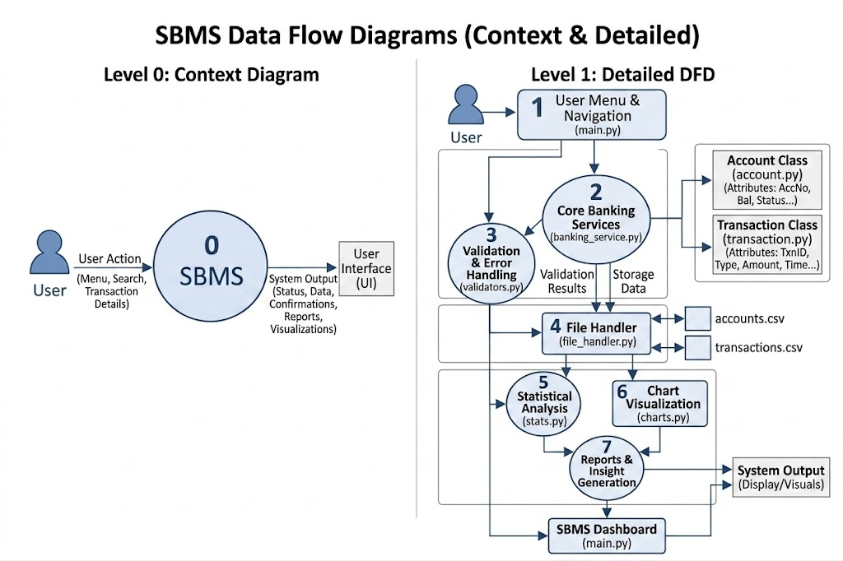

ALGORITHM

->Main Program Algorithm

- Step 1: Start the system and initialize all required variables, database connections, and system resources for smooth execution
- Step 2: Display the main menu with options such as Register, Login, and Exit for user interaction
- Step 3: If the user is new, collect necessary details like name, account type, and initial balance to create a new account
- Step 4: If the user is existing, prompt for username and password to proceed with login
- Step 5: Validate the entered credentials by checking them with stored data to ensure secure authentication
- Step 6: After successful login, display banking operations like deposit, withdrawal, fund transfer, and balance inquiry
- Step 7: Accept the user’s choice and take required inputs such as amount and account number for processing
- Step 8: Perform necessary checks like verifying sufficient balance before executing the transaction
- Step 9: Update the account details and store the transaction record in the database for future reference
- Step 10: Display the transaction result and return to the main menu or terminate the system based on user choice

IMPLEMENTATION

import pandas as pd
from datetime import datetime

# ------------------ Account Class ------------------
class Account:
def __init__(self, acc_no, name, acc_type, balance):
self.acc_no = acc_no
self.name = name
self.acc_type = acc_type
self.balance = balance
self.status = "Active"
self.created_on = datetime.now()

def deposit(self, amount):
self.balance += amount

def withdraw(self, amount):
if self.balance >= amount:
self.balance -= amount
return True
return False

def to_dict(self):
return {
"Account No": self.acc_no,
"Name": self.name,
"Type": self.acc_type,
"Balance": self.balance,
"Status": self.status,
"Created On": self.created_on
}

# ------------------ Transaction Class ------------------
class Transaction:
def __init__(self, acc_no, txn_type, amount):
self.acc_no = acc_no
self.txn_type = txn_type
self.amount = amount
self.time = datetime.now()

def to_dict(self):
return {
"Account No": self.acc_no,
"Type": self.txn_type,
"Amount": self.amount,
"Time": self.time
}

# ------------------ Data Storage ------------------
accounts = {}
transactions = []

# ------------------ Functions ------------------

def create_account():
acc_no = input("Enter Account No: ")
if acc_no in accounts:
print("Account already exists!")
return
name = input("Enter Name: ")
acc_type = input("Enter Type (Savings/Current): ")
balance = float(input("Enter Initial Balance: "))
accounts[acc_no] = Account(acc_no, name, acc_type, balance)
print("Account Created Successfully!")

def deposit():
acc_no = input("Enter Account No: ")
if acc_no in accounts:
amount = float(input("Enter Amount: "))
accounts[acc_no].deposit(amount)
transactions.append(Transaction(acc_no, "Deposit", amount))
print("Deposit Successful!")
else:
print("Account Not Found!")

def withdraw():
acc_no = input("Enter Account No: ")
if acc_no in accounts:
amount = float(input("Enter Amount: "))
if accounts[acc_no].withdraw(amount):
transactions.append(Transaction(acc_no, "Withdraw", amount))
print("Withdraw Successful!")
else:
print("Insufficient Balance!")
else:
print("Account Not Found!")

def transfer():
from_acc = input("From Account: ")
to_acc = input("To Account: ")
amount = float(input("Enter Amount: "))

if from_acc == to_acc:
print("Cannot transfer to same account!")
return

if from_acc in accounts and to_acc in accounts:
if accounts[from_acc].withdraw(amount):
accounts[to_acc].deposit(amount)
transactions.append(Transaction(from_acc, "Transfer", amount))
print("Transfer Successful!")
else:
print("Insufficient Balance!")
else:
print("Invalid Account!")

def view_accounts():
if not accounts:
print("No accounts available!")
return
for acc in accounts.values():
print("\n", acc.to_dict())

def view_transactions():
if not transactions:
print("No transactions yet!")
return
for txn in transactions:
print("\n", txn.to_dict())

# ------------------ Analytics ------------------

def show_stats():
if not accounts:
print("No data for analysis!")
return

balances = [acc.balance for acc in accounts.values()]

print("\n--- Banking Statistics ---")
print("Total Balance:", sum(balances))
print("Average Balance:", sum(balances)/len(balances))
print("Highest Balance:", max(balances))
print("Lowest Balance:", min(balances))

# ------------------ File Handling ------------------

def save_data():
acc_data = [acc.to_dict() for acc in accounts.values()]
txn_data = [txn.to_dict() for txn in transactions]

pd.DataFrame(acc_data).to_csv("accounts.csv", index=False)
pd.DataFrame(txn_data).to_csv("transactions.csv", index=False)

print("Data Saved Successfully!")

# ------------------ Main Menu ------------------

while True:
print("\n===== SMART BANKING SYSTEM =====")
print("1. Create Account")
print("2. Deposit")
print("3. Withdraw")
print("4. Transfer")
print("5. View Accounts")
print("6. View Transactions")
print("7. Show Statistics")
print("8. Save & Exit")

choice = input("Enter choice: ")

if choice == '1':
create_account()
elif choice == '2':
deposit()
elif choice == '3':
withdraw()
elif choice == '4':
transfer()
elif choice == '5':
view_accounts()
elif choice == '6':
view_transactions()
elif choice == '7':
show_stats()
elif choice == '8':
save_data()
print("Exiting System...")
break
else:
print("Invalid Choice!")

INTEGRATION AND SYSTEM TESTING
OUTPUTS

Screen Shots:

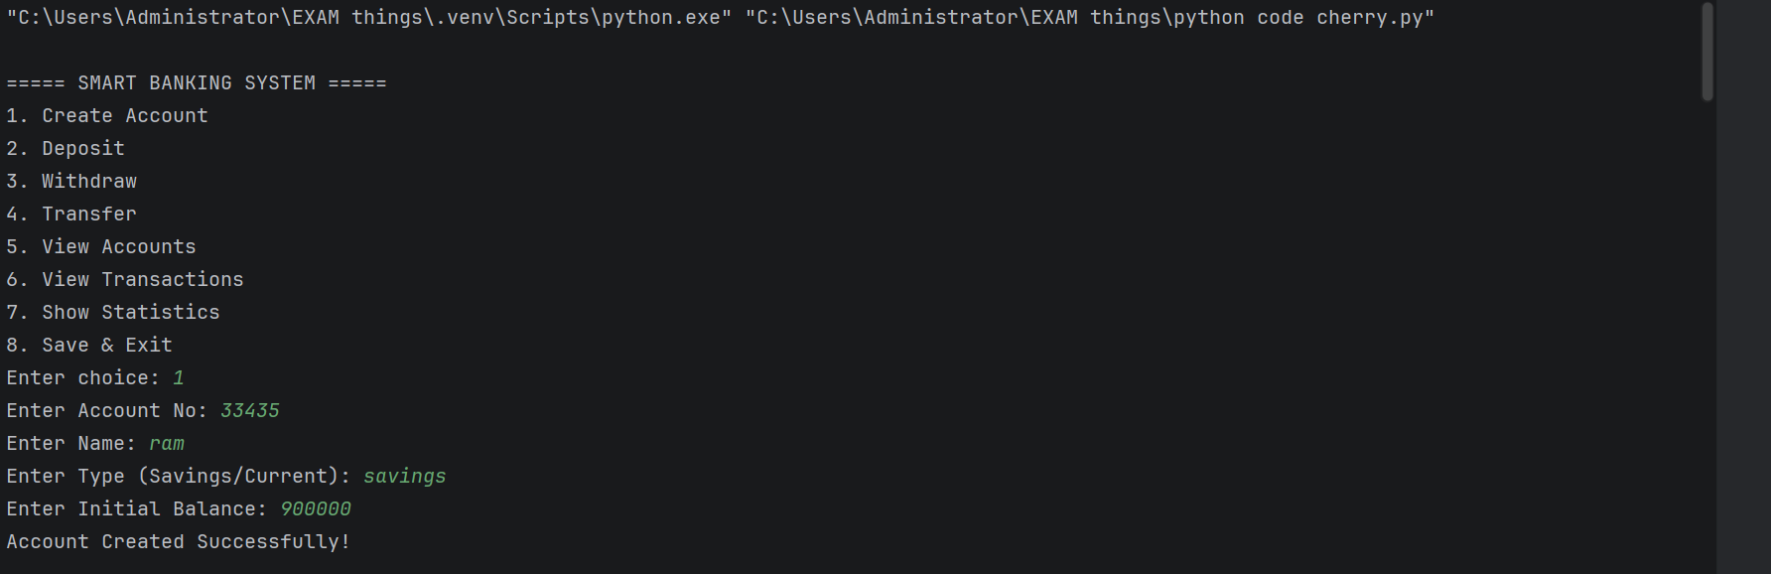
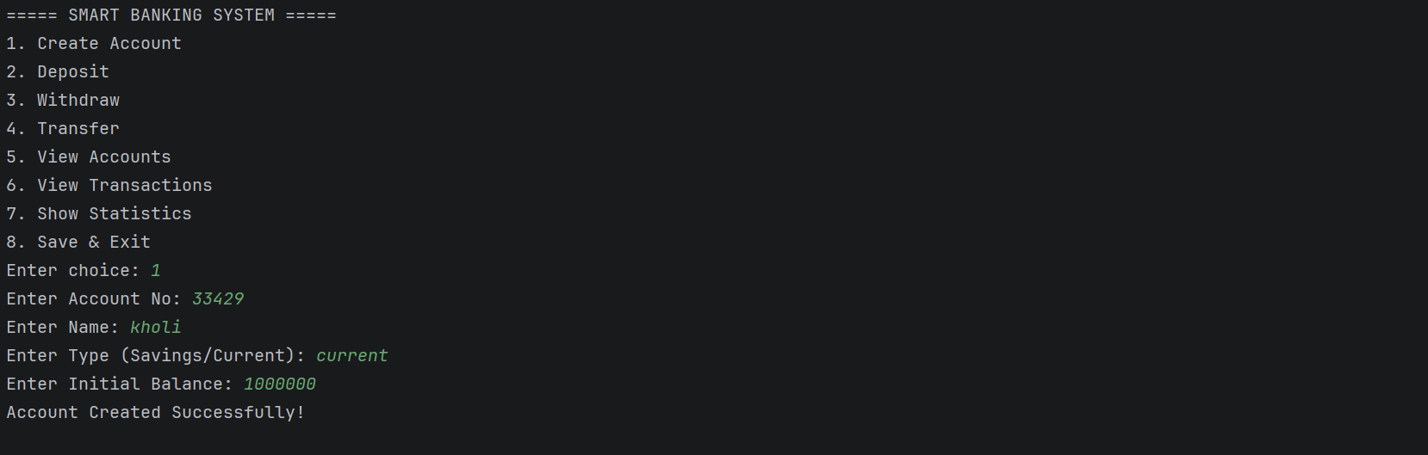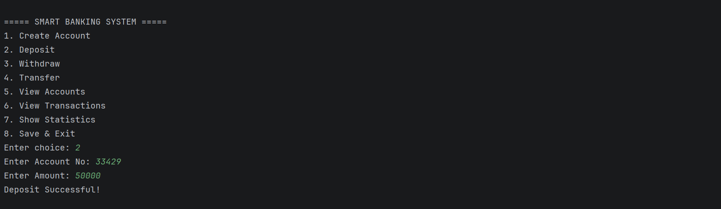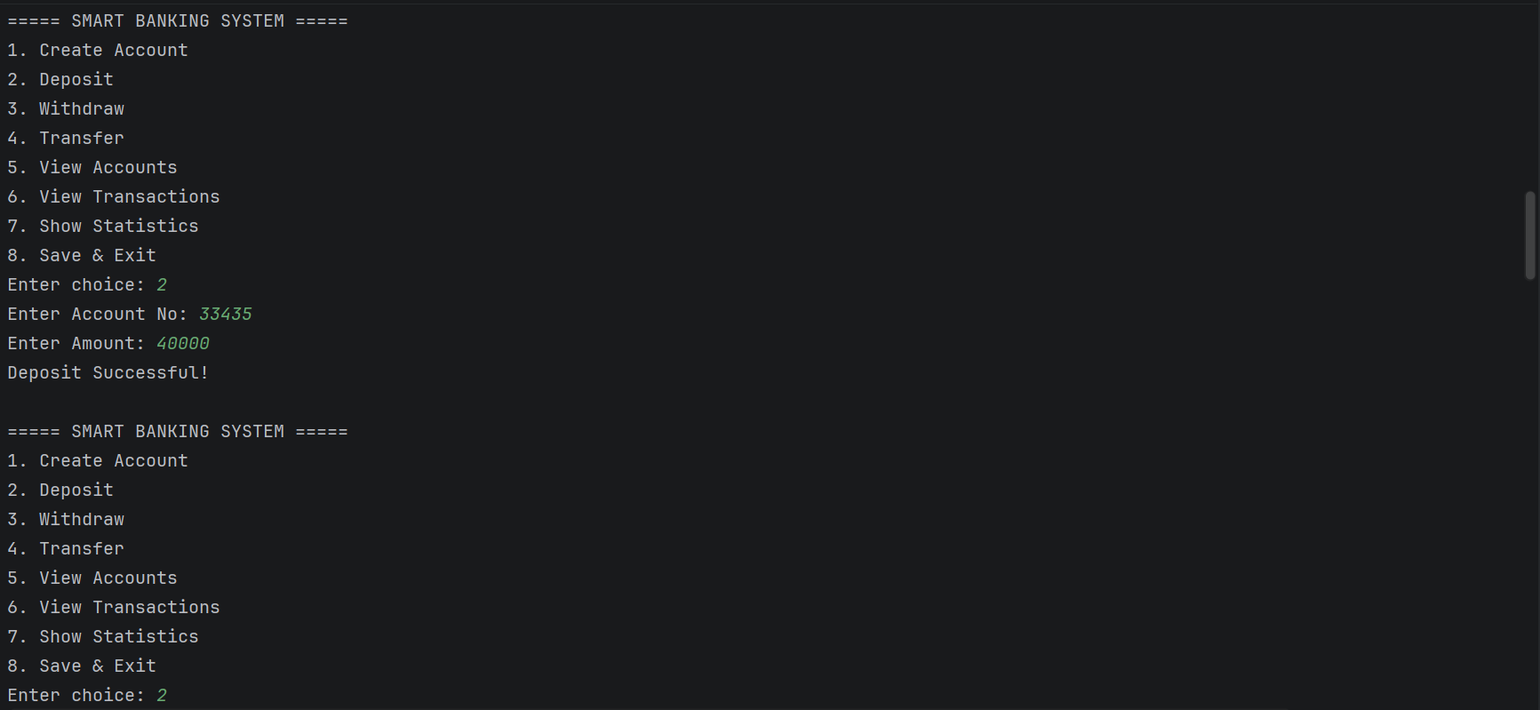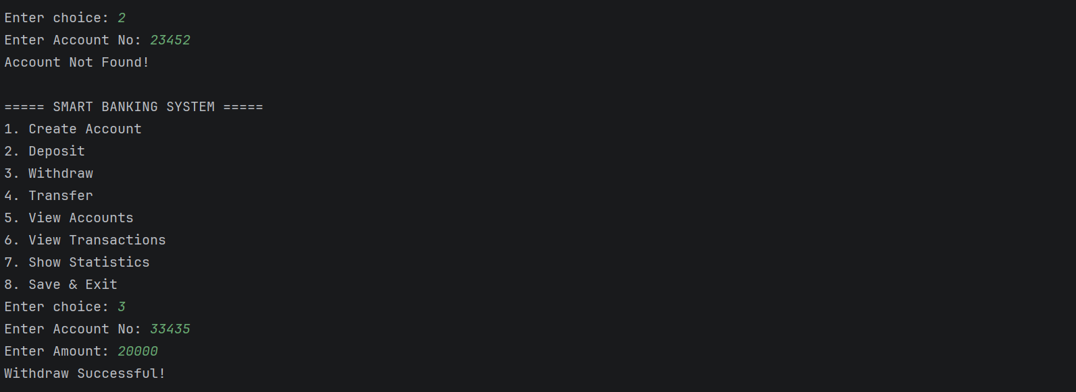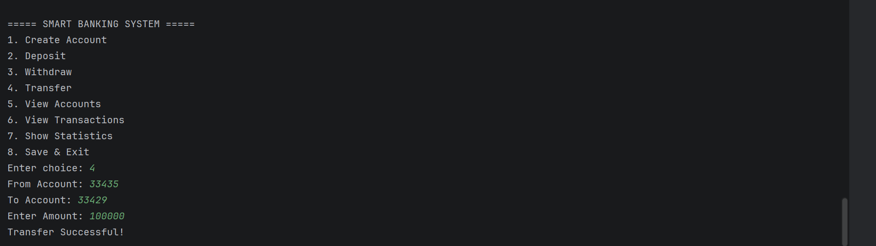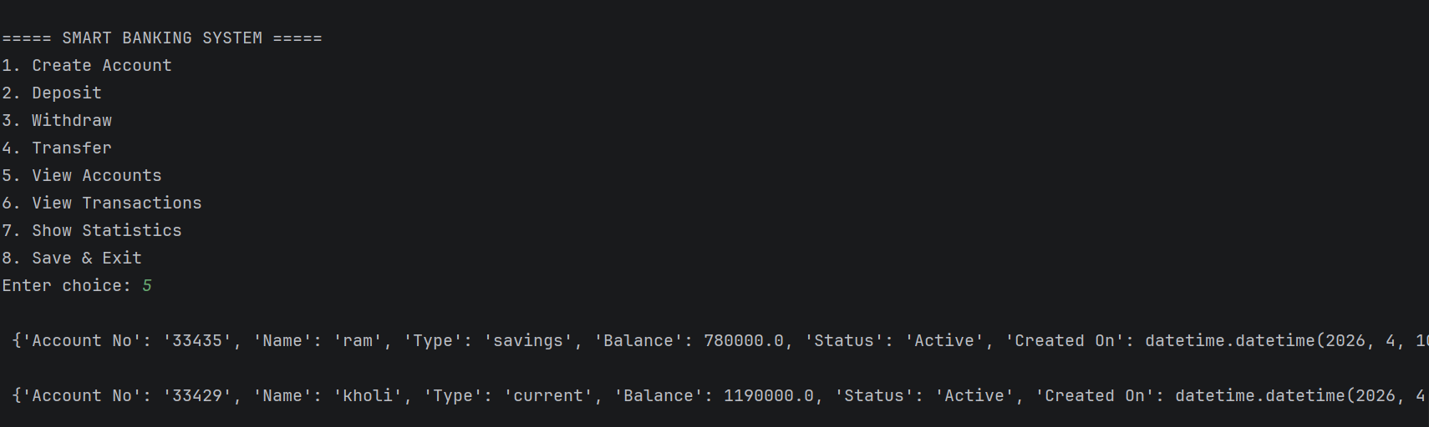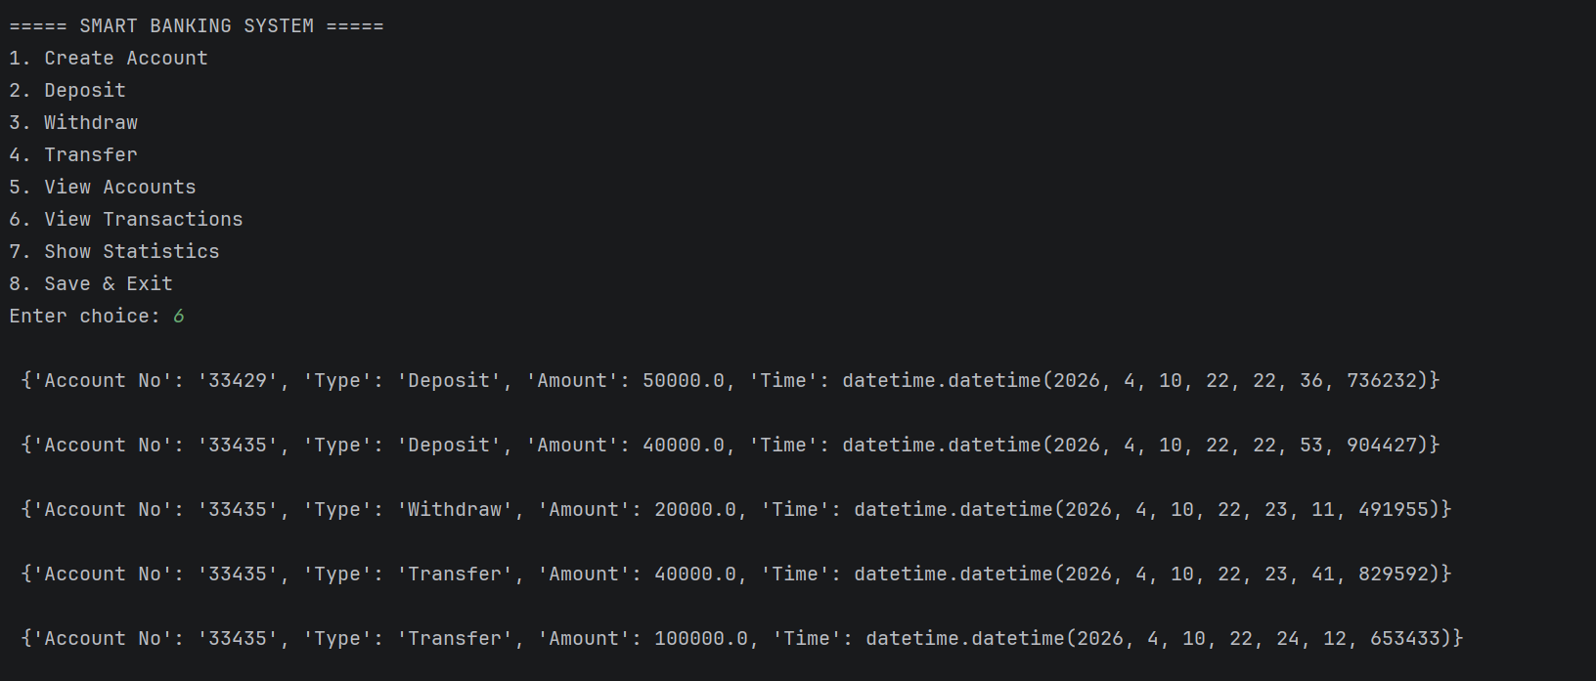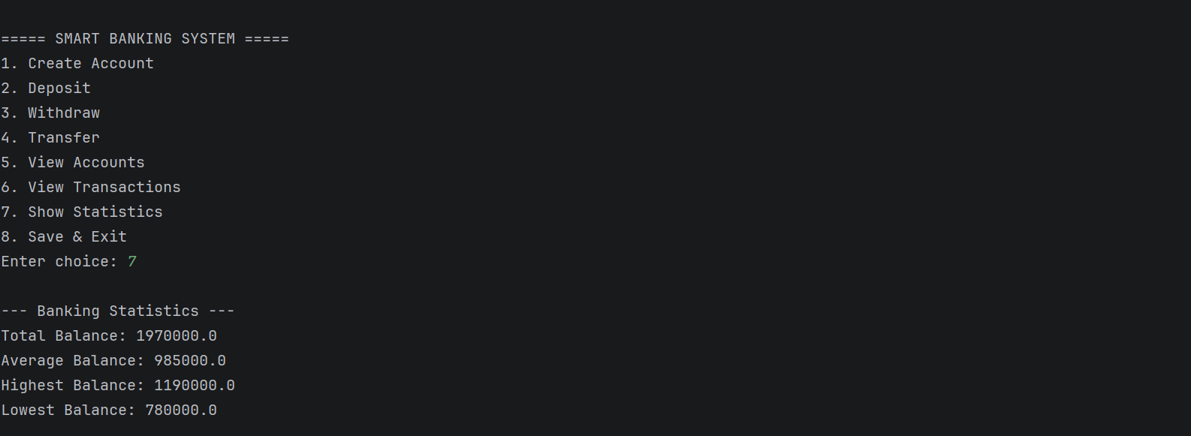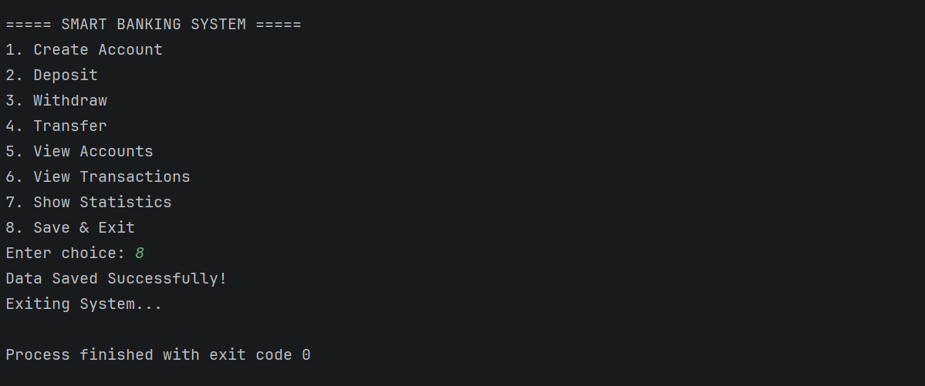

CONCLUSION

The Smart Banking Management System (SBMS) successfully provides a digital solution for managing banking operations efficiently. It simplifies account handling, transaction processing, and data storage in a secure manner. The system reduces manual errors and improves overall performance. It also enhances user convenience by providing quick access to financial information. Thus, SBMS proves to be a reliable and efficient banking solution.

SBMS integrates modern technologies such as OOP, file handling, and data analysis to create a smart banking platform. It ensures accurate transaction management and proper record maintenance. The system also supports data visualization and analytics for better understanding of financial trends. By automating key operations, it reduces workload and increases productivity. Overall, it plays an important role in digital transformation.

The project demonstrates how a simple software system can replicate real-world banking functionalities effectively. It provides a structured and modular approach for easy maintenance and future expansion. The inclusion of validation and error handling ensures system reliability and data safety. With additional enhancements, it can be developed into a full-scale banking application. Hence, SBMS is a valuable tool for both learning and practical implementation.

